

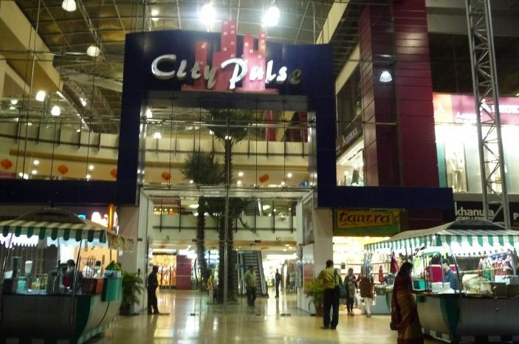

**GOYAL FASHIONS PRIVATE LIMITED (GFPL)**





**About Us**

We are clothing manufacturer managed by technically qualified professionals, being part of the flagship company called Goyal Fashions. The promoters have the background of extensive experience in the field of textiles & clothing business spanning over 4 decades. Our organization has been a leading manufacturer/exporter for the last over 25 years, we have established a name for ourselves in the international market for quality and reliability. The group turnover of the company is about US$ 10 million, in which about 2.5 million contributes to garment business.

### OBJECTIVE

To fulfil the buyers and indirectly the final consumers requirement for quality and value over price. We provide to the buyer and further-on to the final consumer quality merchandise at economical price, a commitment based on mutual trust. The company strives for consistent quality improvements on each level of its operation and has laid thrust on Development activities. On job training for workers is an integral part of its philosophy. Its Personal Department ensures safety and welfare of the employees at the prime agendas of the company to maintain a congenial working atmosphere compatible to the International Standards.

### INFRASTRUCTURE

Our factory in Jaipur cover an area of over 100,000 sq. Ft., with a 300 sewing machines set up, including embroidery, Kaj Buttoning, Washing, Finishing, Checking/QC and Packing. It also houses the administrative office, designing and development and the Fabric/accessory stores.

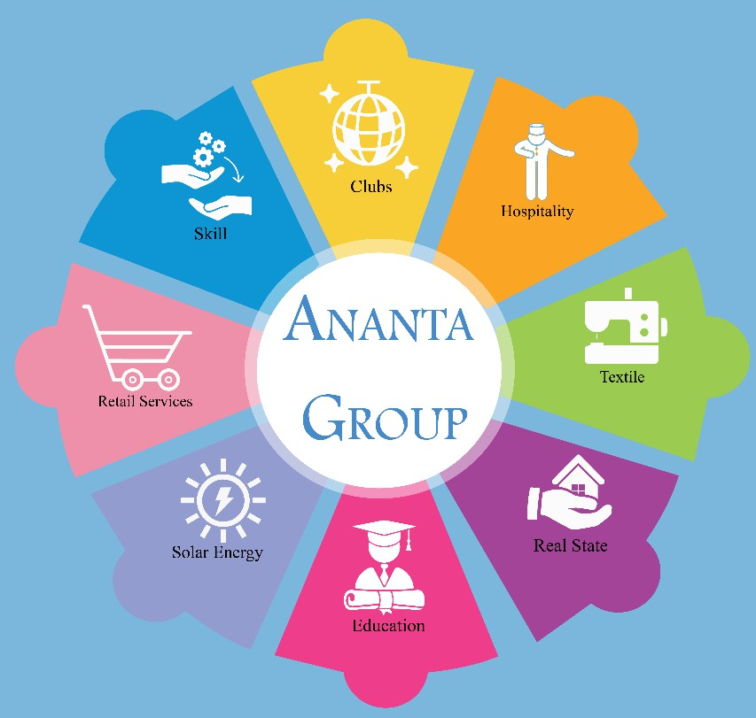**Ananta Groups**

We Ananta Group divided into sectors according to the skill-sets required for the work involved.

* Textile
* Hospitality
* Real Estate
* Club
* Skill
* Retail Services
* Education
* Solar Energy

# OUR SERVICES

We aim to help strengthen the services provided by us and also ensure that our partners will have great experience without any issues.

* Ownership
* Profit Sharing
* Booking
* Negotiation
* Liasioning
* Investors' Meet
* Guidance & Support
* Rental Services
* Complimentary Additional Benefits

# OUR CLIENTS

|  |  |  |
| --- | --- | --- |
| Image result for ananta udaipur logo | Related image | Image result for ananta pushkar logo |
| Related image | work | Image result for Ananta hotel pali logo |

|  |  |  |
| --- | --- | --- |
| work | work | Image result for Ananta hotel ranthambore logo |
| Image result for Ananta hotel kota logo | Image result for Ananta hotel ranthambore logo | C:\Users\ASUS\AppData\Local\Microsoft\Windows\INetCache\Content.MSO\E7FE54A4.tmp |

**OUR SKILL DEVELOPMENT PROJECTS**

## [Transform rural poor youth into an](http://goyalfashions.co.in/) [economically independent and globally](http://goyalfashions.co.in/) [relevant workforce](http://goyalfashions.co.in/)

An instrumental role in supporting the social and economic programs of the government like the Make in India, Digital India, Smart Cities and Start-Up India, Stand-Up India campaigns.

## [Integrated education and livelihood](http://goyalfashions.co.in/) [initiatives for minority communities](http://goyalfashions.co.in/)

Key benefit to minority youths who do not have a formal school leaving certificate, i.e. those in the category of school- dropouts or educated in community education institutions. In order to provide them formal education and skills.

## [If we have to move India towards development](http://goyalfashions.co.in/) [then Skill Development should be our mission.](http://goyalfashions.co.in/)

RSLDC address the challenges of unemployment and ensuring gainful and sustainable employment by formulating appropriate and innovative strategies for the poor and vulnerable people.

## To encourage skill development for youth by providing monetary rewards for successful completion of approved training programs.

PMKVY objective of this Skill Certification Scheme is to enable a large number of Indian youths to take up industry- relevant skill training that will help them in securing a better livelihood.

## RSTP generate short term training programmes which are concerned for skill development in Trainees.

Regular Skill Training Programme (RSTP) — aimed at training people for self-employment. RSTP managed to train 14,134 youths out of the targeted 26,000.

## To create opportunities for the development of talent within the country and improve the overall scope and space for underdeveloped sectors.

NSDC aims to catalyse skilling initiatives that can potentially have a multiplier effect in the economy, while striving to involve the industry in all aspects of skill development.



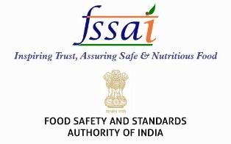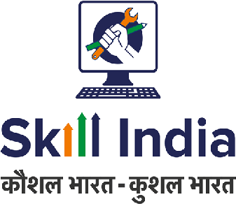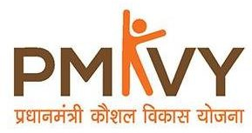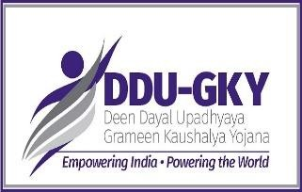

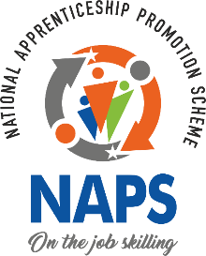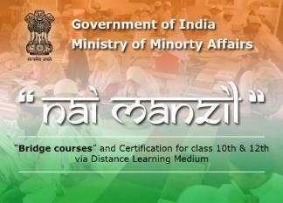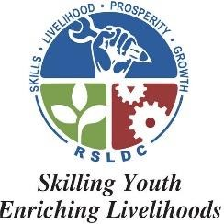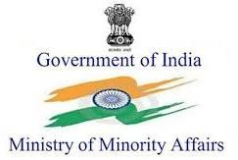

**GOYAL FASHIONS (P) LIMITED**

24, Goyal House, Ajmer Road, Jaipur- 302006 Email: [gfpl.skill@gmail.com](mailto:gfpl.skill@gmail.com) goyalfashions.co.in

